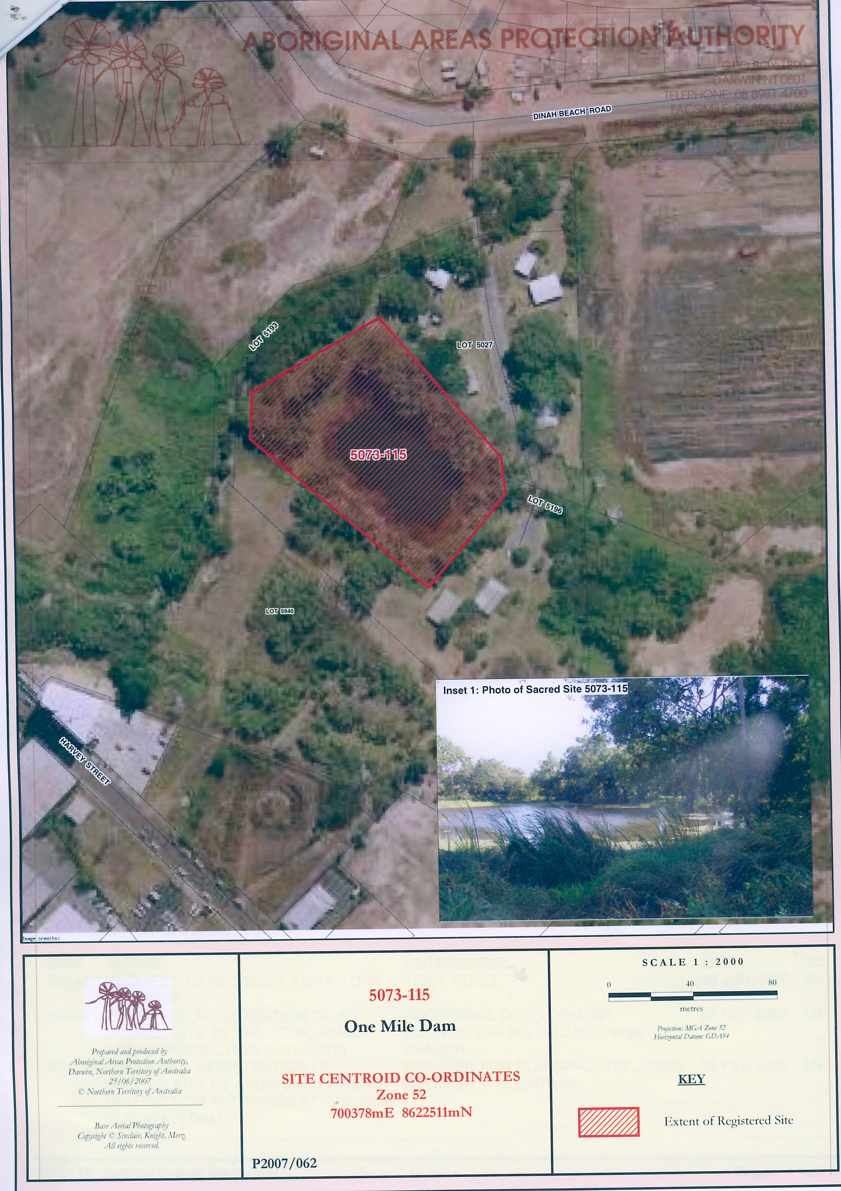
Above: Registered site and housing at OMD, 2009.

